
www.kingston-saddlery.com
QUALITY ALWAYS WINS
875 STILLWATER ROAD SUITE 200 WEST SACRAMENTO, CA 95605
Phone: (916)996-0711 Fax: (530)753-4505
E-mail: kingstonsaddlery@yahoo.com & sales@kingston-saddlery.com
ASSEMBLY OF THE CARRIAGE
INSTALL AXLE ----------------------------------------------------------------------------------------------------------- -2-
Groupware ------------------------------------------------------------------------------------------------------------- -2-
Installation ------------------------------------------------------------------------------------------------------------- -2-
Finished Picture ------------------------------------------------------------------------------------------------------- -2-
INSTALL FOOTPLATE-------------------------------------------------------------------------------------------------- -3-
Groupware ------------------------------------------------------------------------------------------------------------- -3-
Installation ------------------------------------------------------------------------------------------------------------- -3-
Finished Picture ------------------------------------------------------------------------------------------------------- -3-
INSTALL THE SHAFT --------------------------------------------------------------------------------------------------- -4-
Groupware ------------------------------------------------------------------------------------------------------------- -4-
Installation ------------------------------------------------------------------------------------------------------------- -4-
Accomplishment ------------------------------------------------------------------------------------------------------ -4-
INSTALL SINGLETREE ------------------------------------------------------------------------------------------------ -5-
Groupware ------------------------------------------------------------------------------------------------------------- -5-
Installation ------------------------------------------------------------------------------------------------------------- -5-
Accomplishment ------------------------------------------------------------------------------------------------------ -5-
INSTALL THE SEAT AND WHEELS--------------------------------------------------------------------------------- -6-
Groupware ------------------------------------------------------------------------------------------------------------- -6-
Installation ------------------------------------------------------------------------------------------------------------- -6-
manufactory INFORMATION----------------------------------------------------------------------------------- -7-
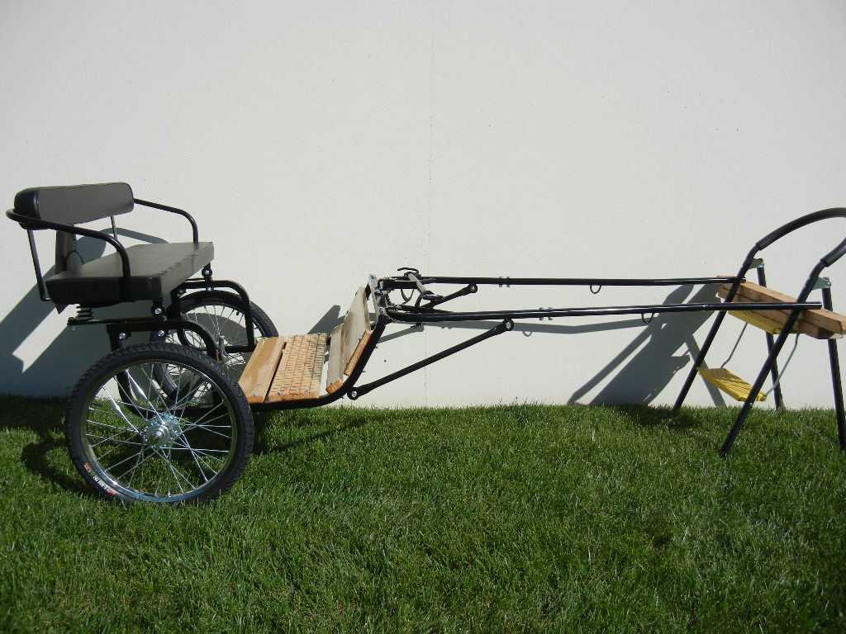
Product code: C2204.48-55, C2214.48-55, C2184.48-55, C2244.48-55, C2204.53, C2214.53, C2184.53, C2244.53
Remark:
Color: Black
Strong, rugged design with wood floor, hardwood (or iron) singletree and a comfortable cushioned seat for two with a backrest. Open design for easy entry and exit (can appended railing).
We offer solid rubber tires, motorcycle wheels, chrome rim 24" wheels (20" on Mini size). Metal shafts standard.
1、INSTALL AXLE
GROUPWARE
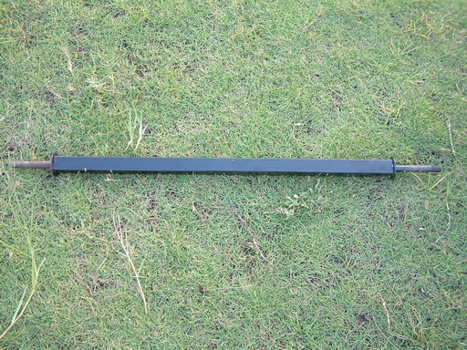 | 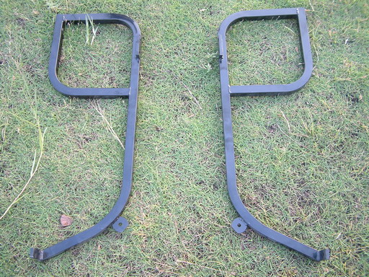 |  | 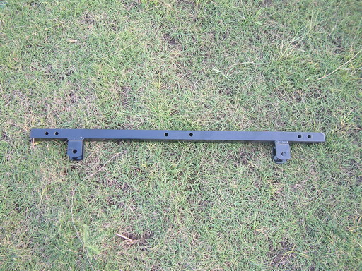
（1）AXLE | （2）BODYWORK(TWO PARTS) |  | （3）BODYWORK reinforcement
INSTALLATION
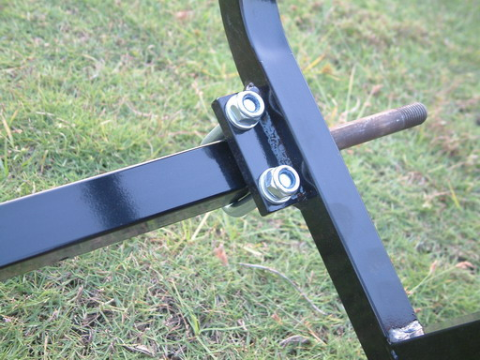 |  | 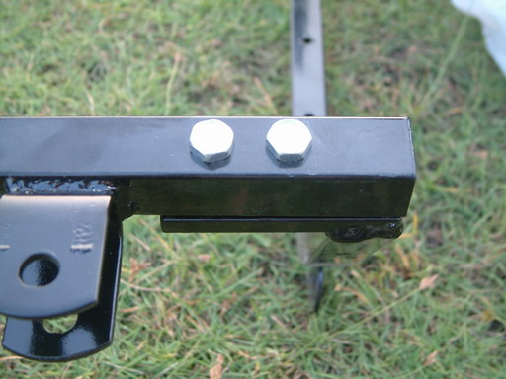
Tighten (1) into (2) by “U”-bolt. |  | Tighten (3) with the foreside of (2) by spanner
FINISHED PICTURE
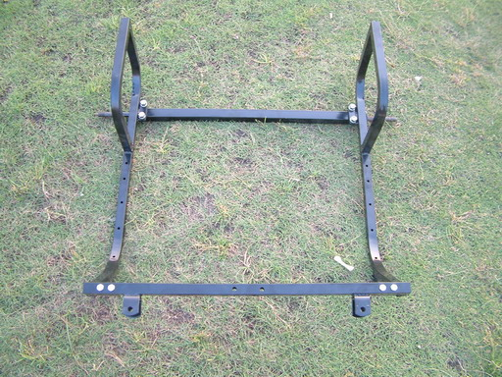
（4）BODYWORK + AXLE
2、INSTALL FOOTPLATE

GROUPWARE
 | 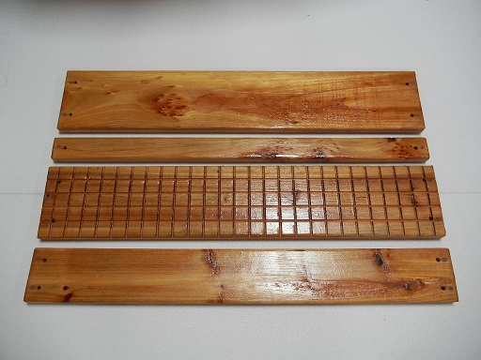
（4）SEAT + AXLE | （5）FOOTPLATE(4 piece of a set)
INSTALLATION
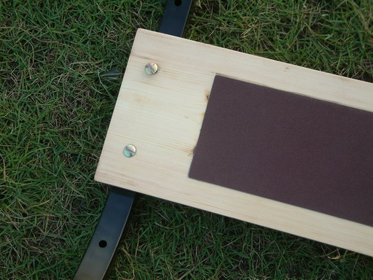 | 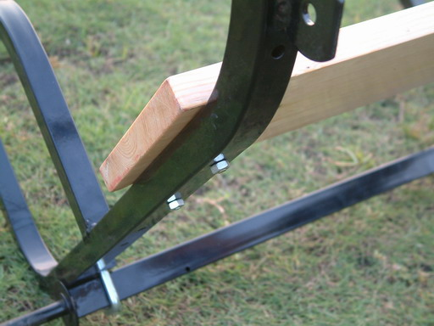
Put the footplate on the bodywork and tighten it to bodywork with bolt (×8), the footplate with skidproof surface must be placed second. | Tighten the other wood footplate on the bodywork.
FINISHED PICTURE
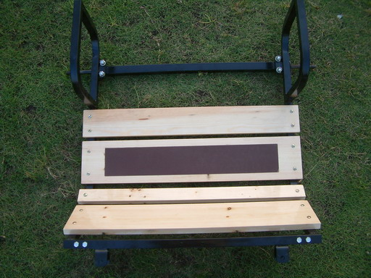
（6）BODYWORK + AXLE + FOOTPLATE

3、INSTALL THE SHAFT

GROUPWARE
 | 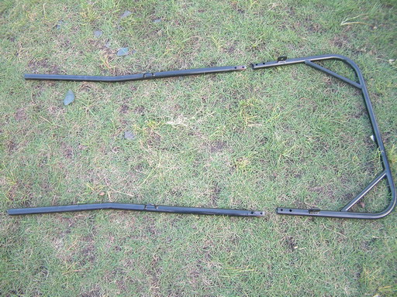 | 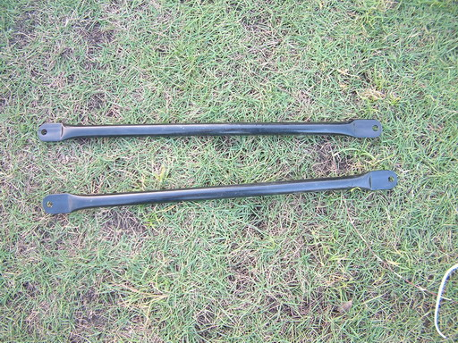
（6）BODYWORK+AXLE+ FOOTPLATE | （7）SHAFT（three parts） | （8） BRACKET
INSTALLATION
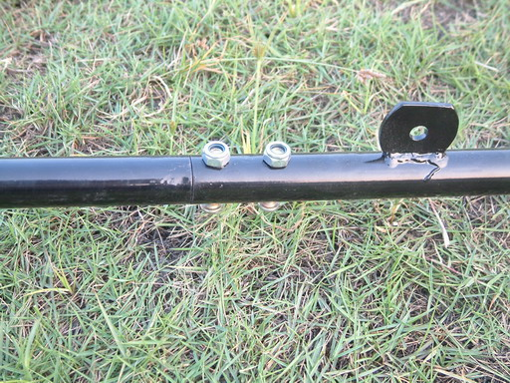 | 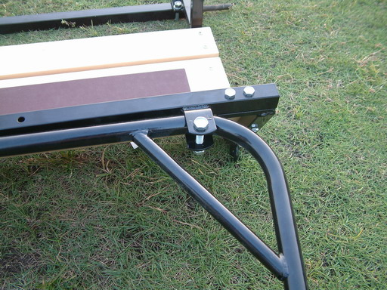 |  | 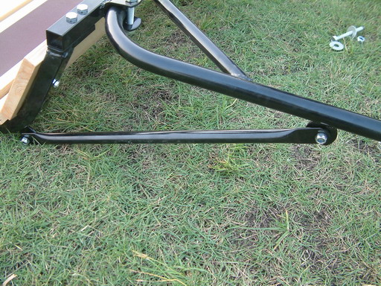
join the 3 parts of shaft into 1 whole shaft, tighten them by bolts（×4） | Install (7) to the U-style groove in front of (6) and tighten it with bolts（×2）. |  | Fix one side of (8) on (7) by nut, fix another side of (8) on (6) by nut
ACCOMPLISHMENT
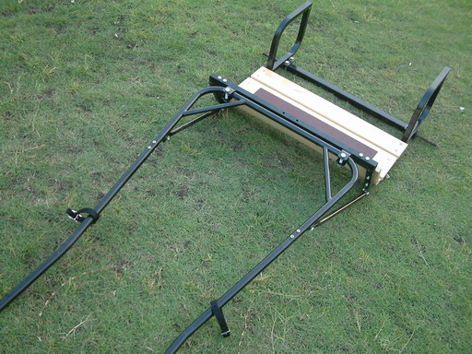
（9）MAIN CARRIAGE ASSEMBLY

4、INSTALL SINGLETREE

GROUPWARE
 | 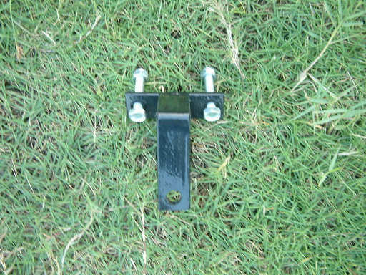 |  | 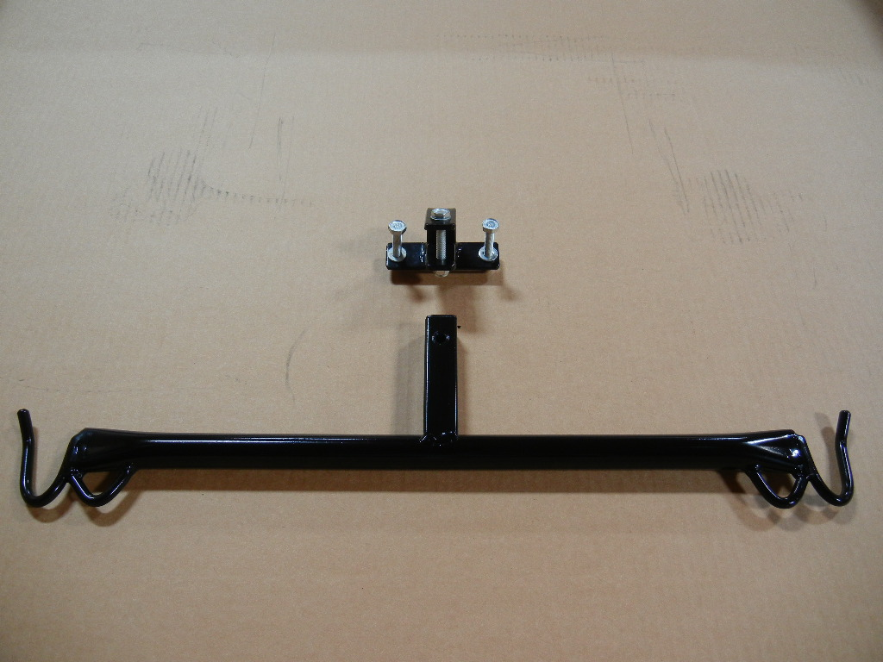
（9）MAIN CARRIAGE ASSEMBLY | （10）BAR CONNECION |  | （11）SINGLETREE
INSTALLATION
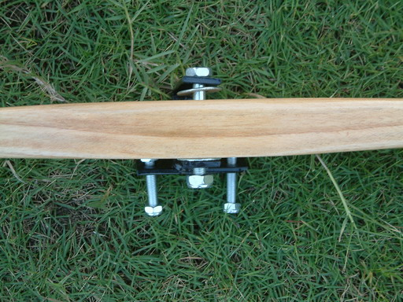 |  | 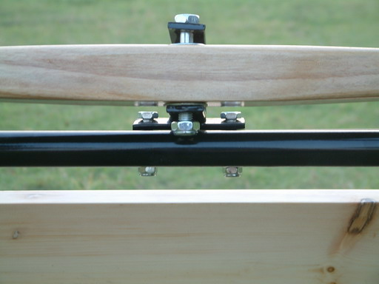
Add two washers on the top and bottom of the (11), put them into the groove of (11). Tighten (10) and (11) by bolt and nut. |  | Fix (10) on the front rail of bodywork by bolt and nut.
ACCOMPLISHMENT
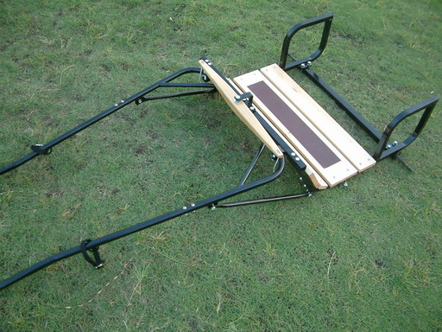
（12）MAIN CARRIAGE ASSEMBLY

5、INSTALL THE SEAT AND WHEELS

GROUPWARE
 | 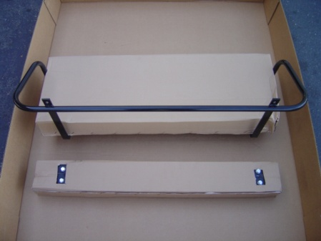 | 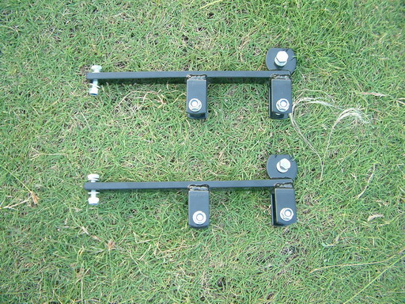 | 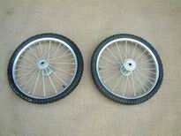
（12）MAIN CARRIAGE ASSEMBLY | （13）SEAT | （14）SEAT CONNECTION AND SUSTAINTATION PIECES（×2） | （15）WHEELS
INSTALLATION
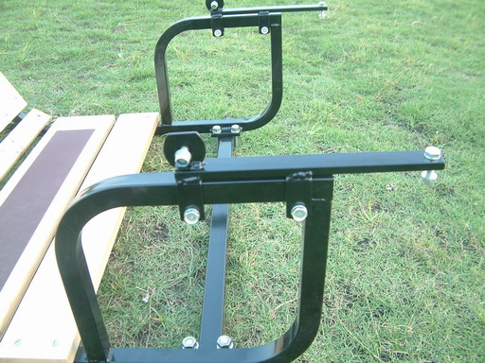 |  | 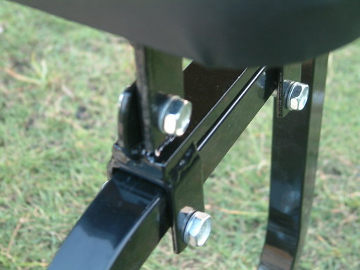
Fix one side of (14) on the horizontal frame of the (12) by bolt and nut, and tighten it with spanner. Then fix another side |  | Fix of (13) and (14)by transverse nut  NOTICE: NOT SO TIGHTEN  Set the bolt to the anti shake spring of (13), revolve (13) so that the bolt can be put into the hole of (14). Fix the nuts on lengthways, and fix the transverse nut.
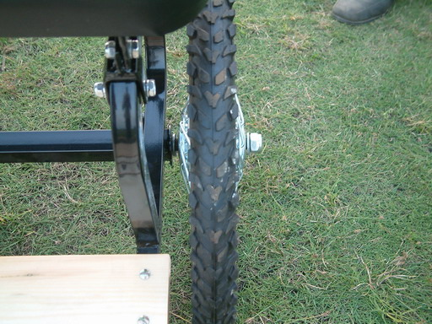 |  | 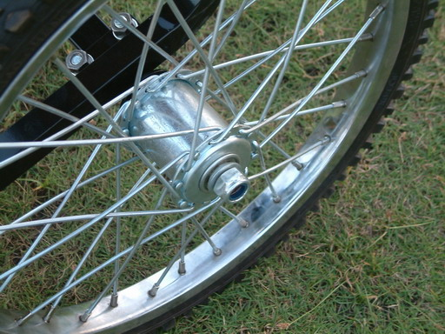
Put the washer on the axle and then install the wheels (5). Again put the washer on the axle outside, and tighten it with the nut.  NOTICE: THE NUT SHOULD NOT BE TOO TIGHT. |  | Another wheel is installed just as the same procedure.
FINISHED ASSEMBLY

